|  |  |  |  |
| --- | --- | --- | --- |
| C:\Users\Joseph\Desktop\instagram_profile_image.png |  | Date Set: 01.04.2019  Deadline: 05.05.2019 | |
| **Name of our team:**  **Databus** |  | **Name of our project:** **UzCommunity** |  | |
|  |  |  |  | |

| [Github Repo (click the link)](https://github.com/iuthub/design-project-databus) | | [Web site link (click the link)](https://databus.000webhostapp.com/) | |
| --- | --- | --- | --- |
|  |  |  |  |

| ID | Surename | Name | Section |
| --- | --- | --- | --- |

|  |  |  |  |
| --- | --- | --- | --- |
| U1710044 | Ganiev | Aziz | 17-7 |
| U1710309 | Khudayberganov | Yusufjon | 17-7 |
| U1710052 | Musyaev | Ruslan | 17-8 |
| U1710287 | Rustamova | Malika | 17-8 |
| U1710178 | Ibragimova | Makhsudakhon | 17-8 |
| U1710147 | Tulaganova | Sevinch | 17-8 |

|  |  |
| --- | --- |
|  |  |
| ÐÐ°ÑÑÐ¸Ð½ÐºÐ¸ Ð¿Ð¾ Ð·Ð°Ð¿ÑÐ¾ÑÑ inha logo |  |



Brief description and activities of the company

Our project is designed to help people to communicate and find solutions to occurring problem. Let’s assume you want to know what the new macro market has, or how good is the restaurant that opened next to your house, or is the particular seller providing fresh and tasty goods, or any other informational problems you may have concerning your hometown.

You can leave the comment to the already existing post and share your experience about that or another problem. This feature gives a chance to deeply understand the solution to the occurring problem. Another cool feature is putting likes and dislikes to particular post, indicating that the post may be misleading or inappropriate.

Our company provides the chance for the citizens of any country to share their personal experience about particular service, products, events and many other things, as well as to gain information.

Our company workers provide stable and user-friendly platform to write the issues that clients are interested in.

Clients can be anyone of a particular region, who will have a chance to address any issue.

**Landing page:**

Navigation bar

Gives an opportunity for the users to directly go to sign up, sign in or contact pages



It is flexible so if the size changes these three pages hide, for not taking up space



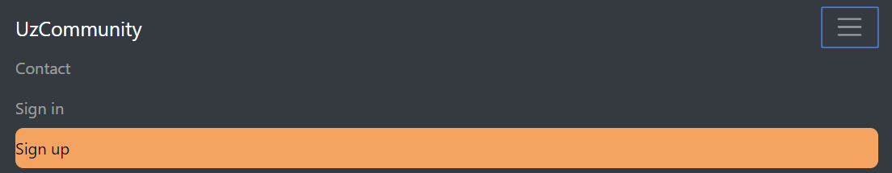

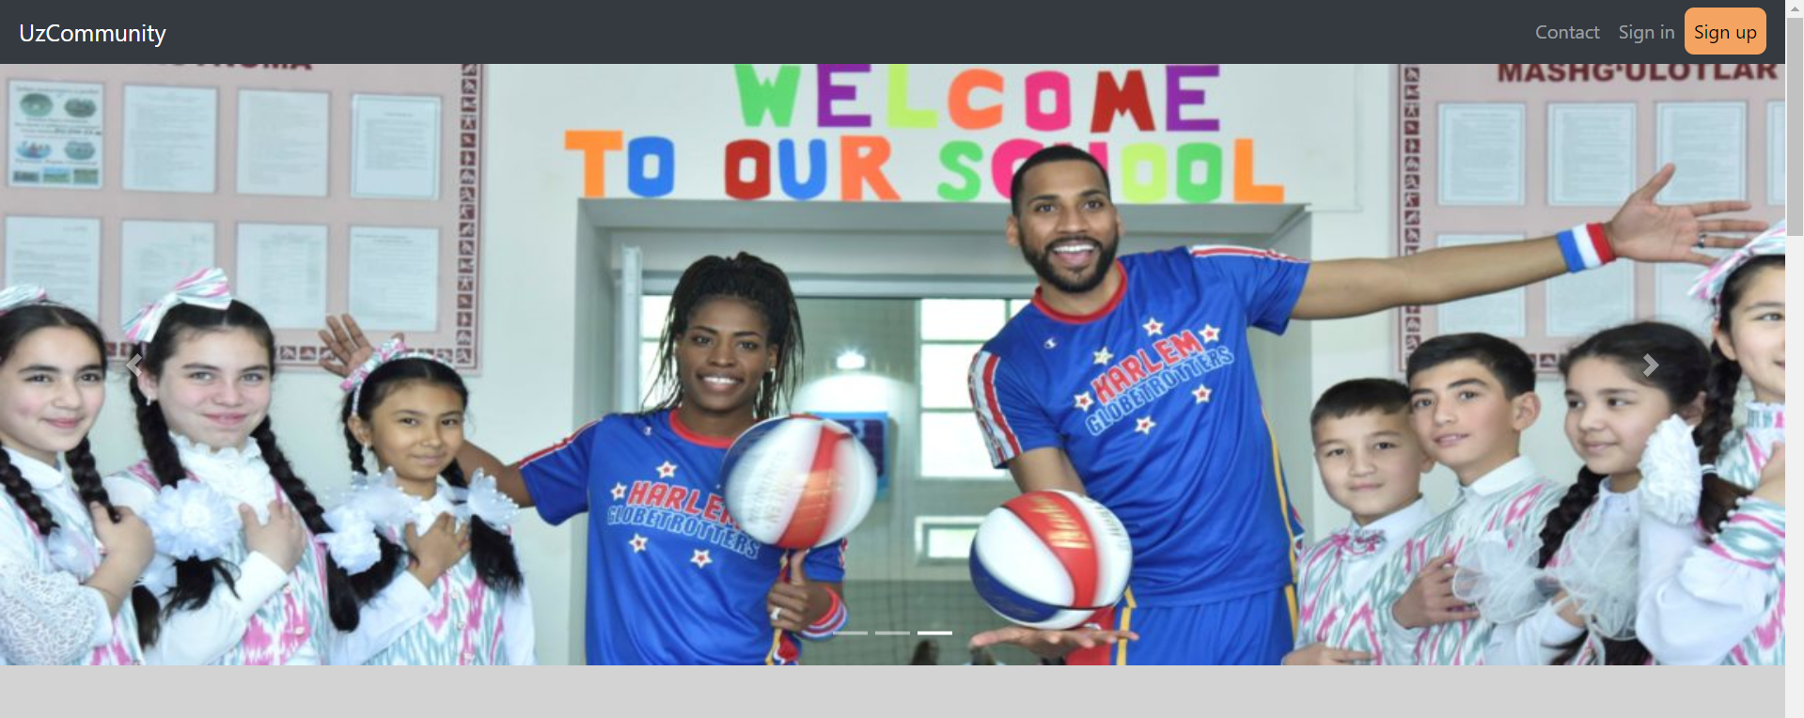

**Screenshots**

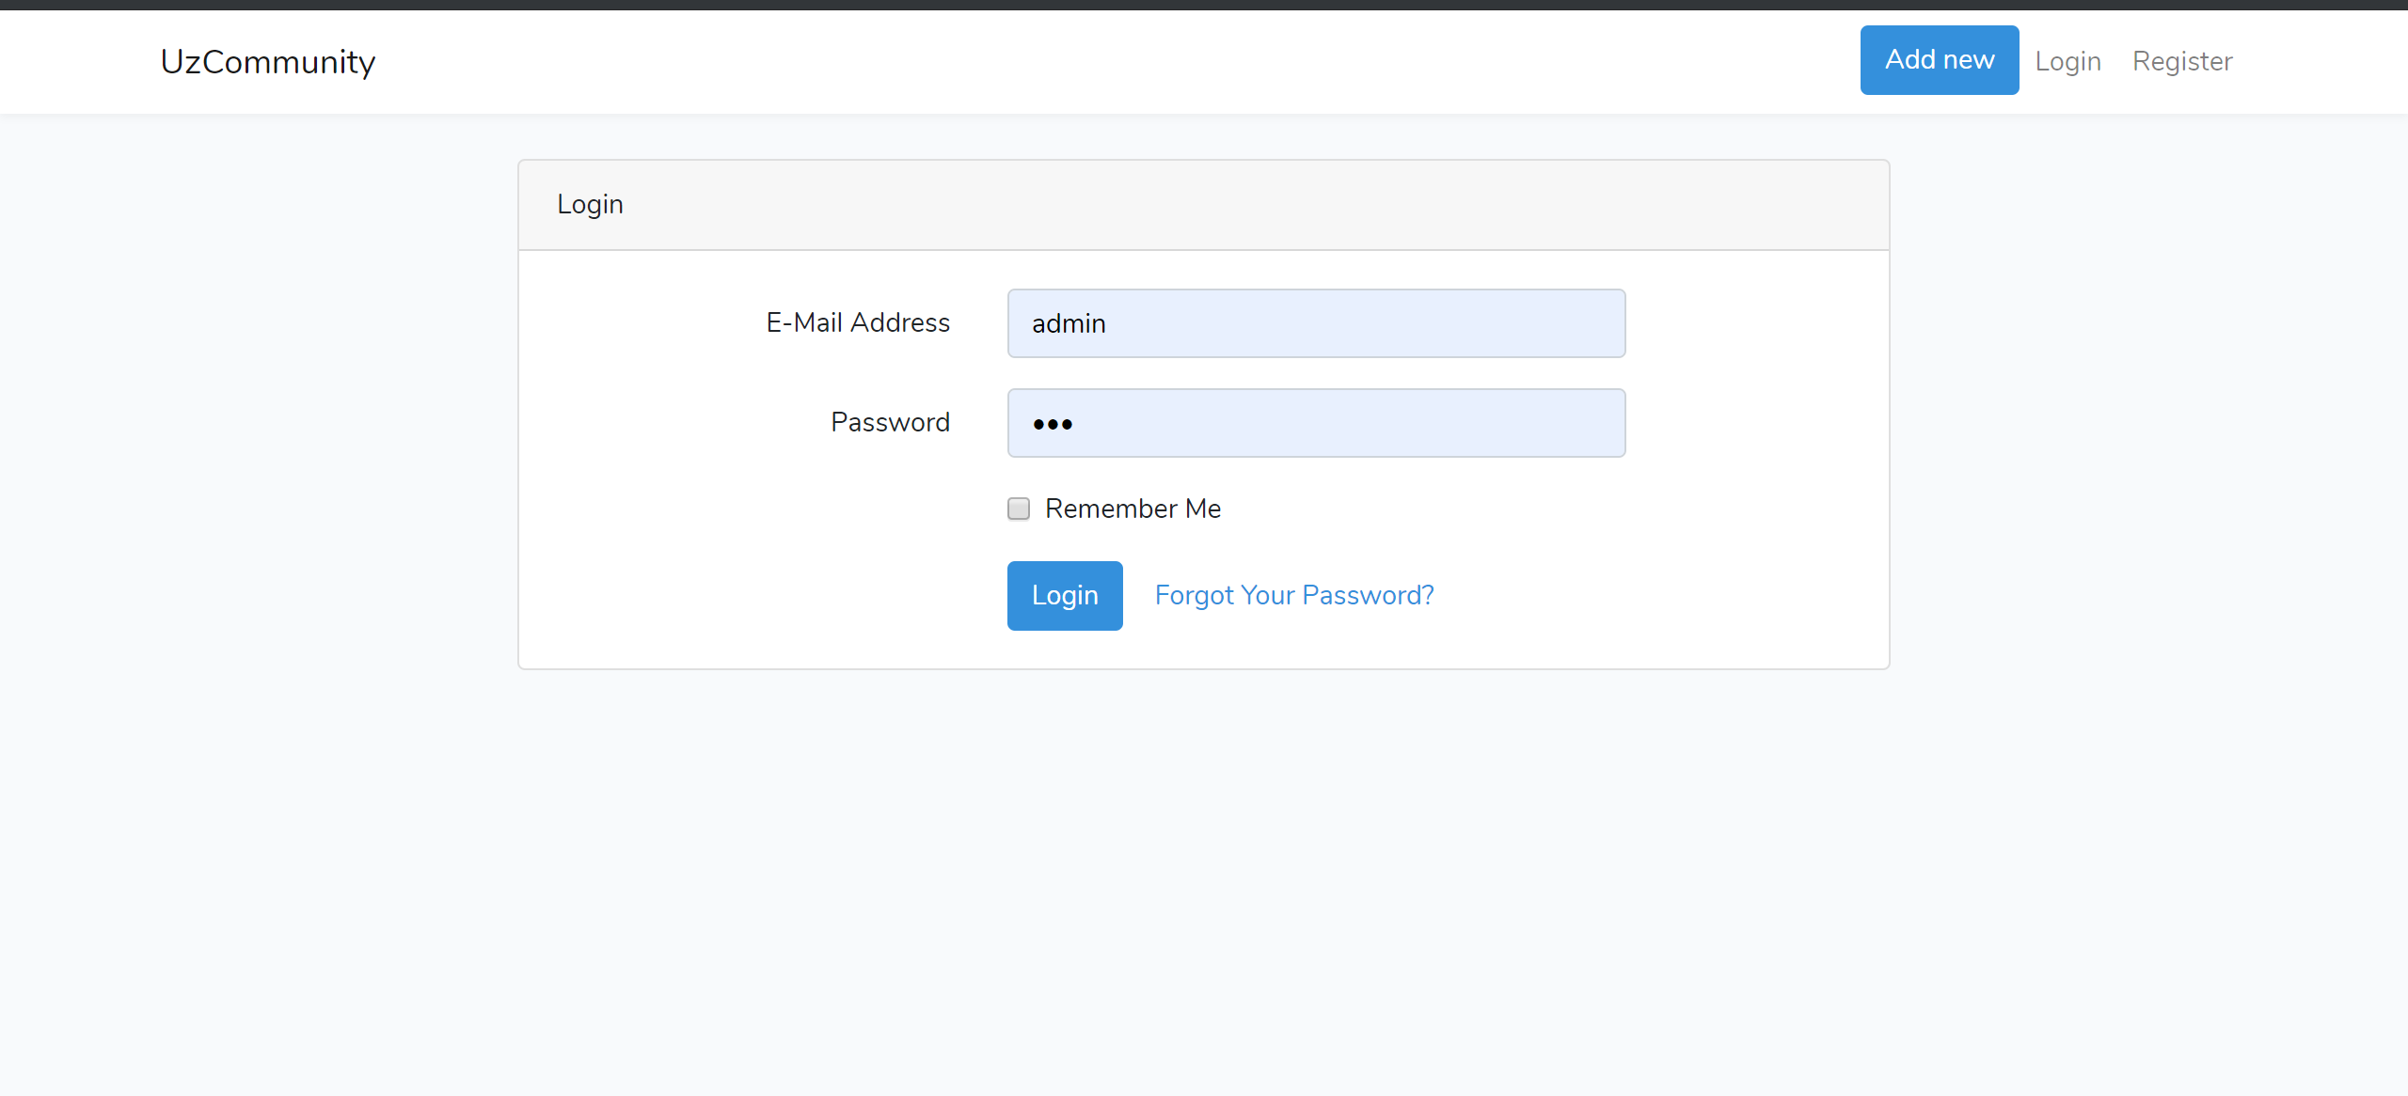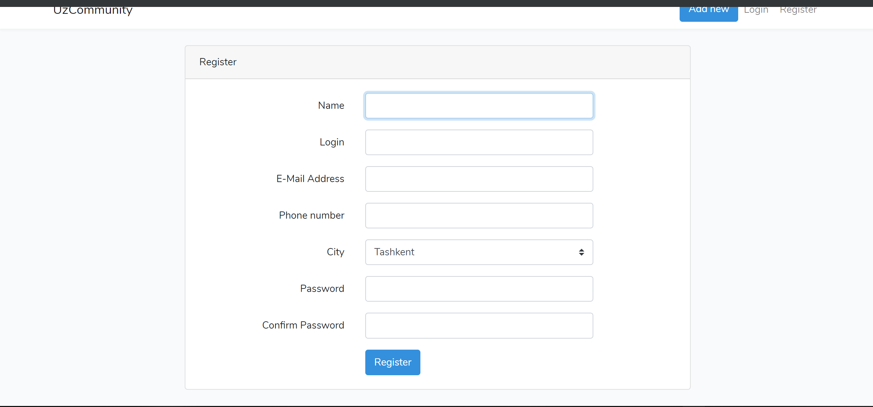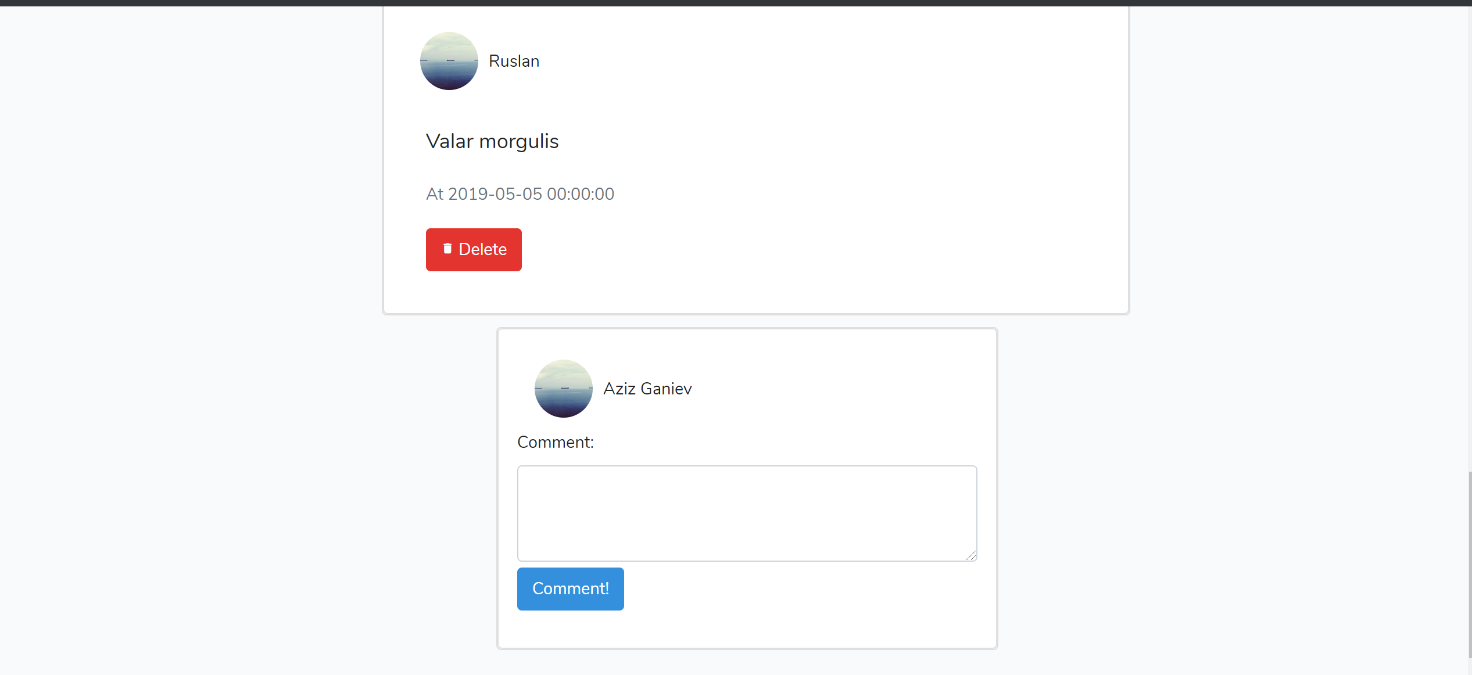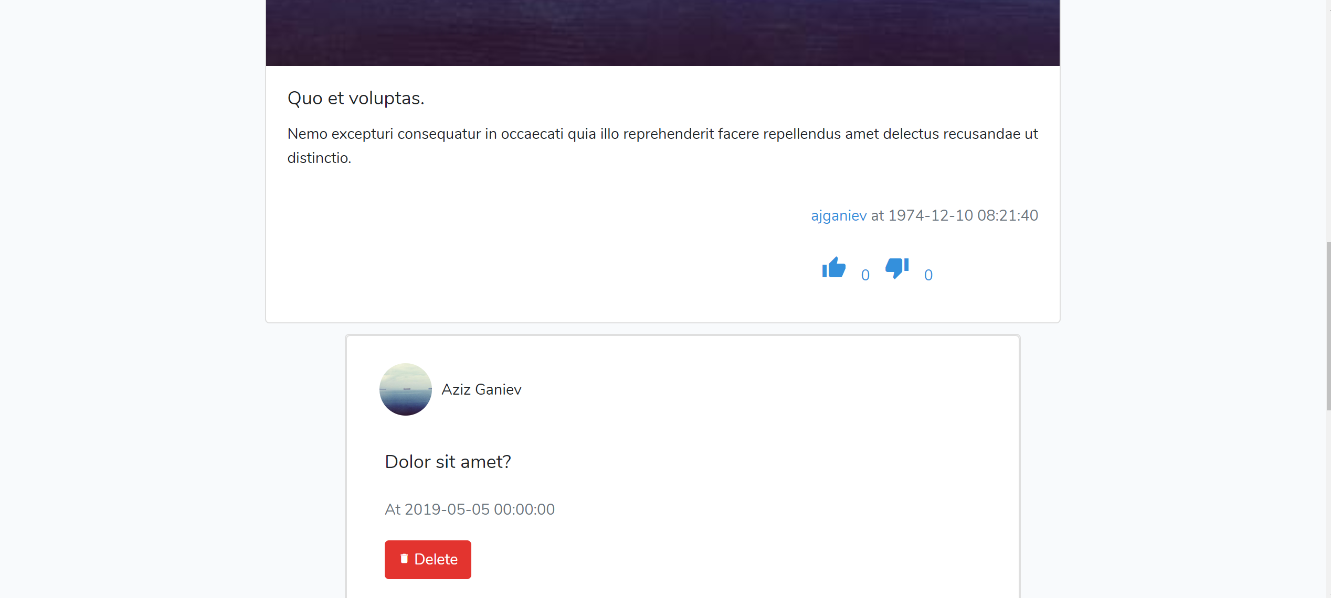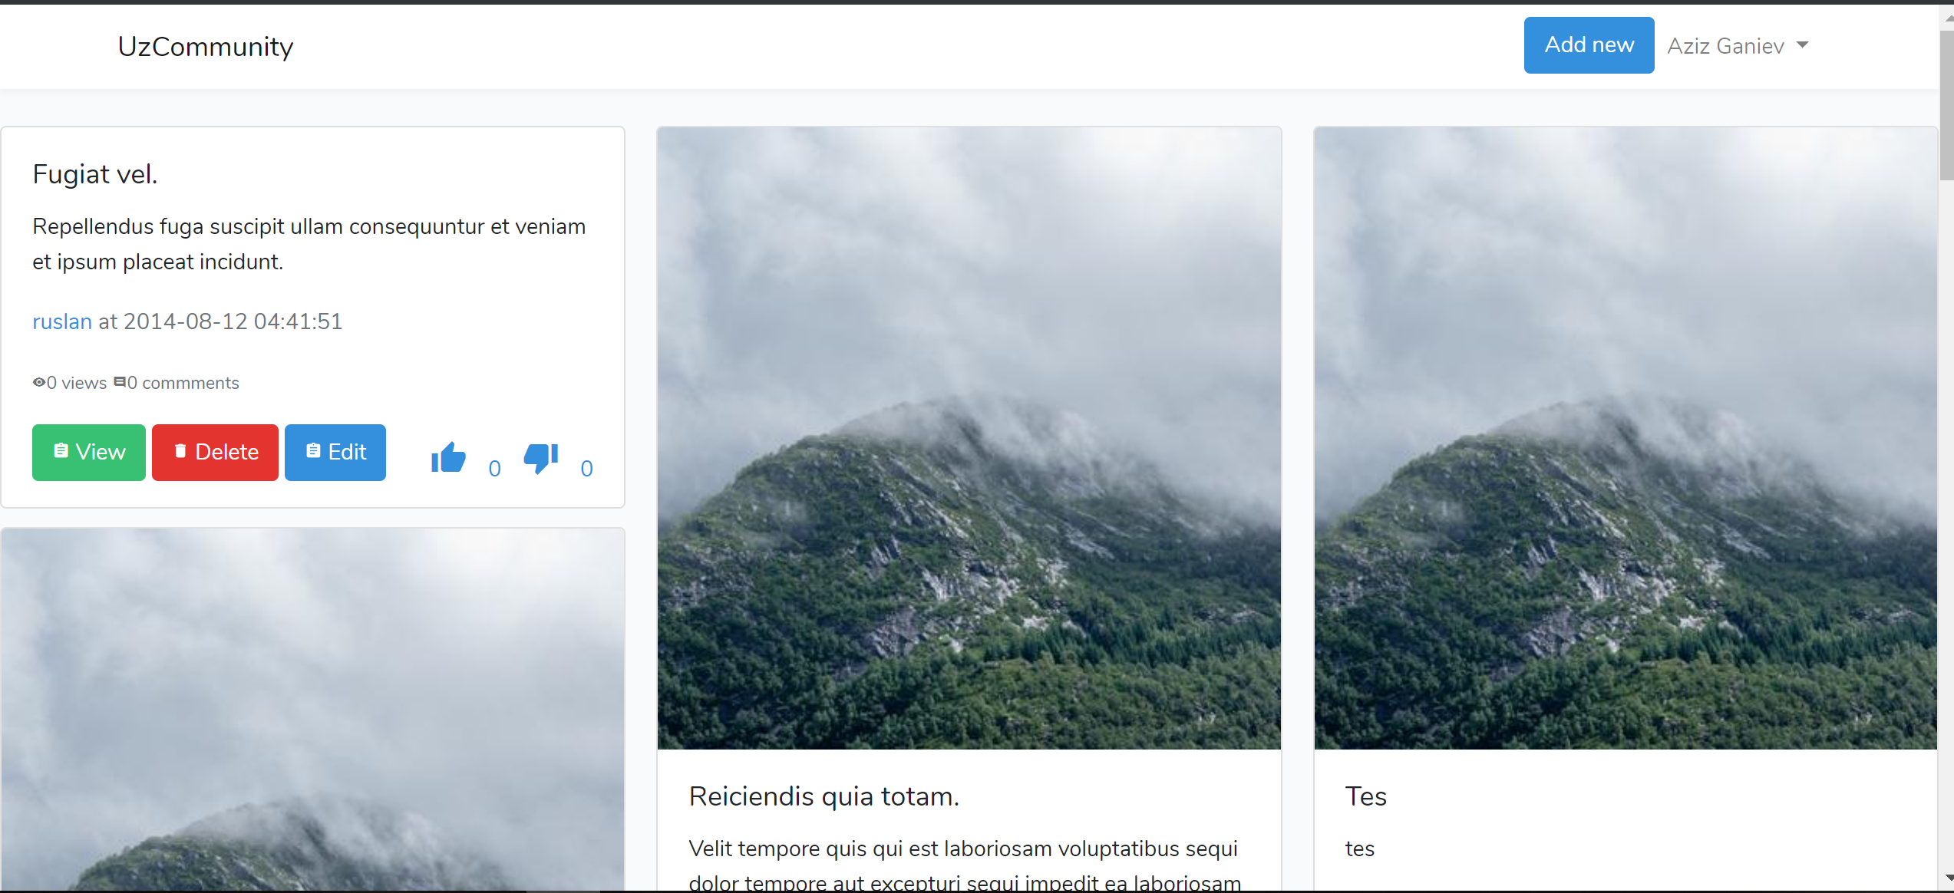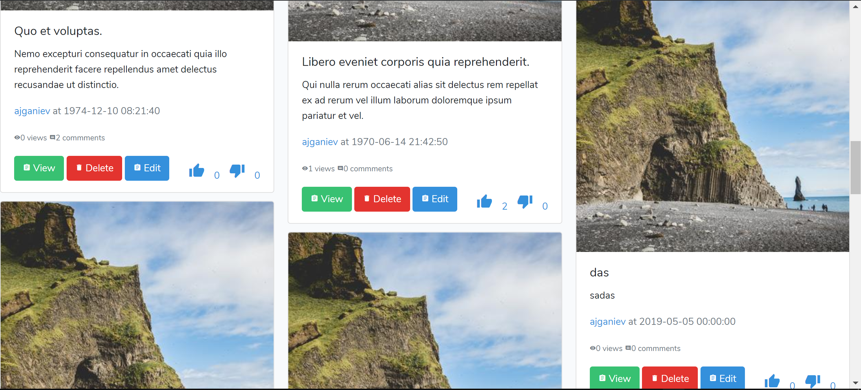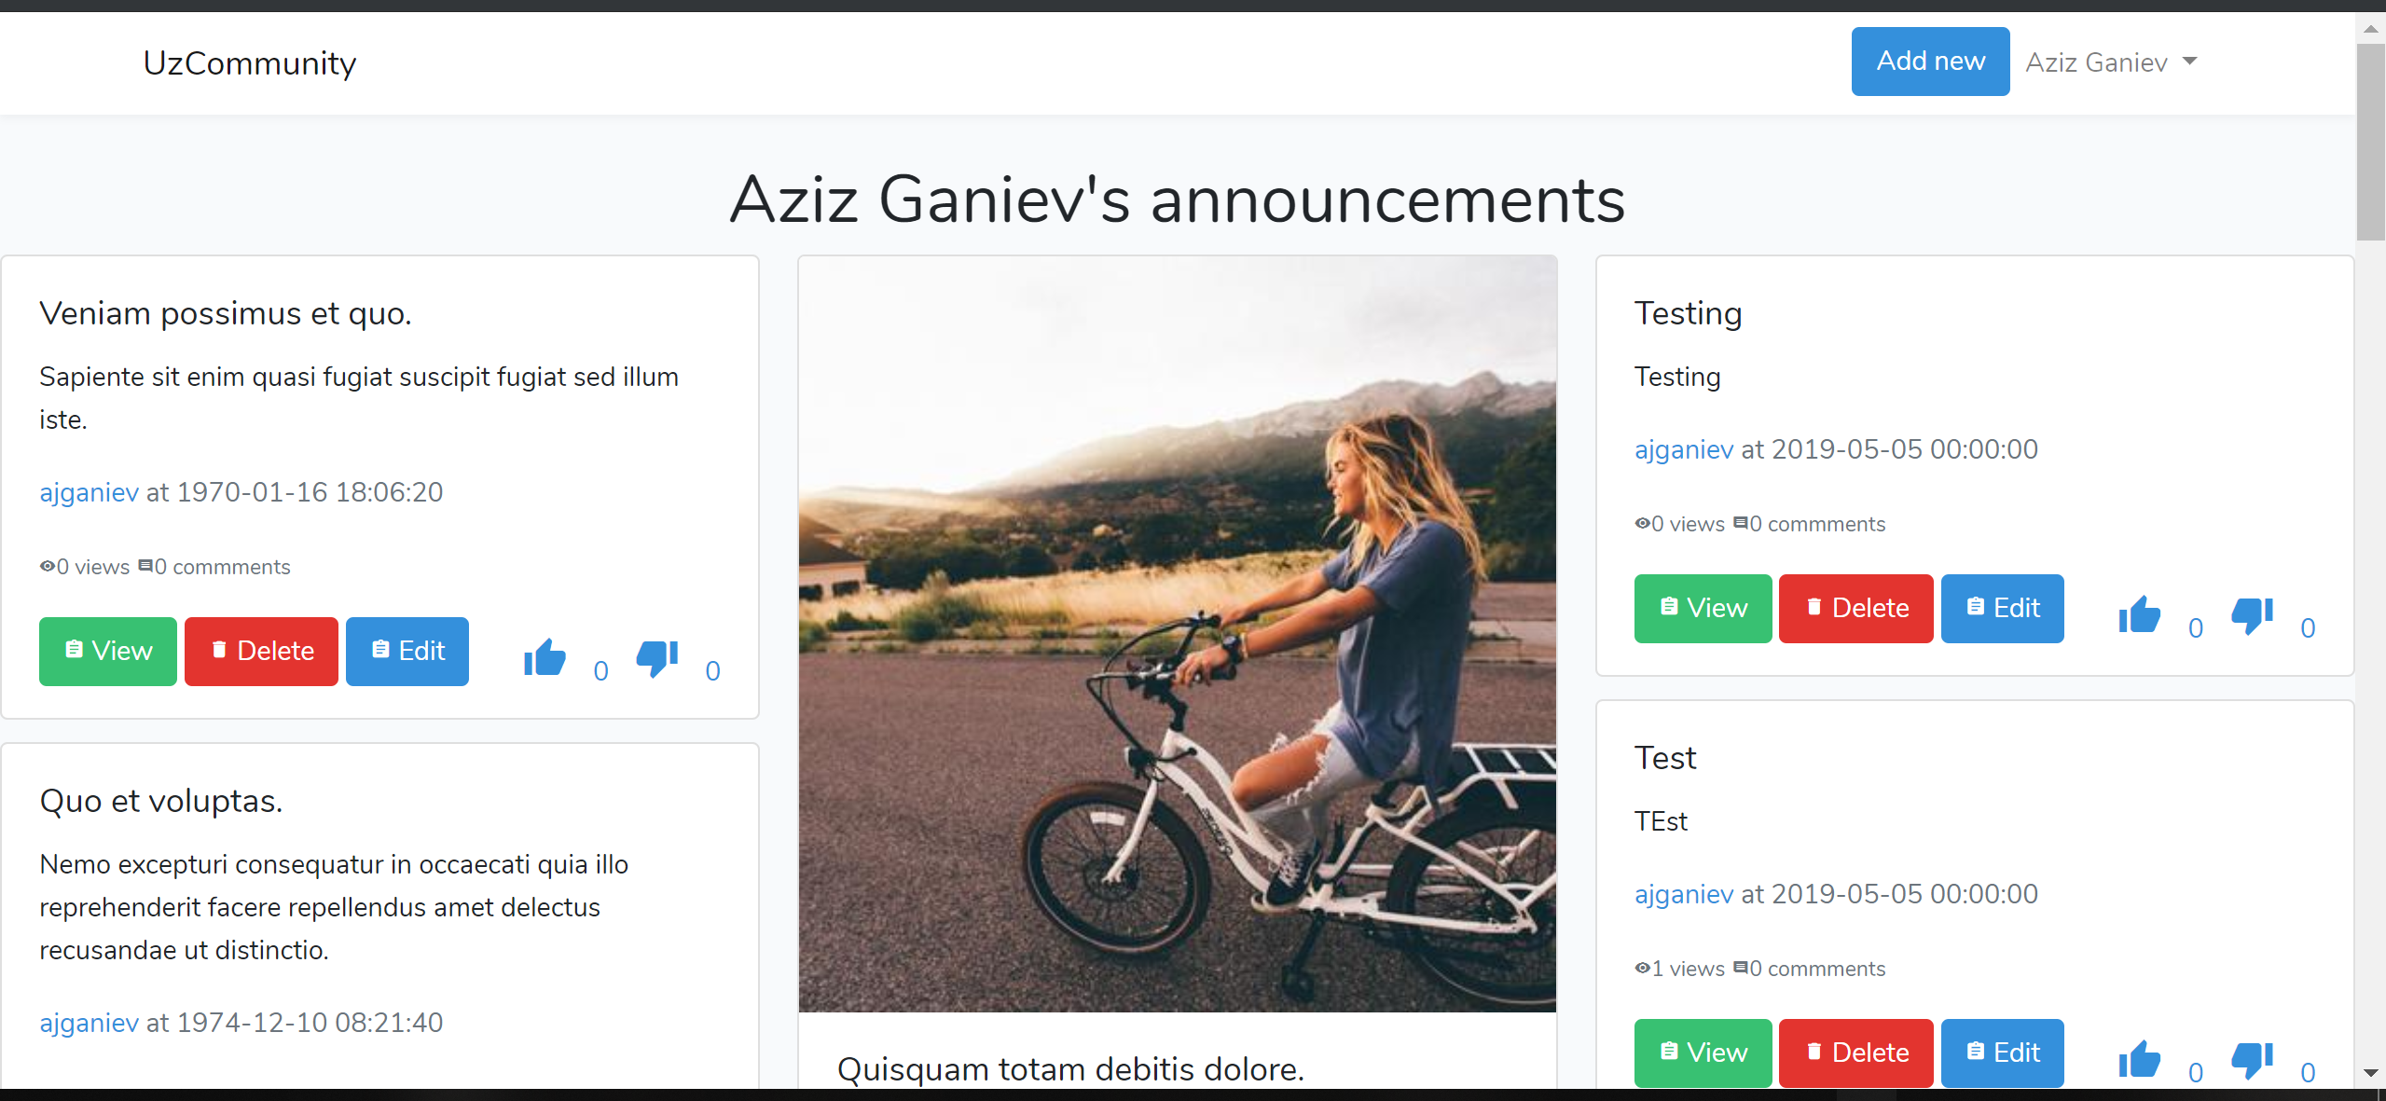

**SUMMARY**

Aziz was literally the proctor of the project, because he had experience with the front-end, as well as the back-end and server side programming.

Yusufjon made contributions in making landing page, posts page, wrote controllers for the web site and so on.

Makhsuda contributed in front-end and database setup. She made login, password pages, made contributions on creating tables in database and many more.

Ruslan helped on making back-end as well as the front-end. He worked mostly on making posts pages and made considerable contribution to the project.

Malika worked in front-end, specifically in making landing page. To make interactive landing page she used different layouts.

Sevinch worked on making comments page and mostly was working with the bootstrap.

**LOGINS AND PASSWORDS**

Admin:

Login: admin password: admin

User:

Login: user password: user